Donald Tucker

[donald@dtucker.xyz](mailto:donald@dtucker.xyz)

Industrial Engineer with manufacturing experience applying data analysis and lean principles in process improvement initiatives, cost savings estimates, time studies, capacity analysis, production work schedules, production rate modifications, staffing requirements, and production metrics.

**Skills**

Python, SQL, Tableau, Business Objects, Power Query, Exploratory Data Analysis, Regression, Machine Learning, Process Improvement, Capacity analysis

**Experience**

### Lockheed martin

### 11/2022 – Present

## Industrial Engineer Mgr, Lockheed martin- Aero F35

Manager leading a team of Industrial Engineers to develop metrics, data analytics, process improvement opportunities, resources allocation, and constraint mitigation plans.

### 10/2019 – 11/2022

## Industrial Engineer Asc Mgr, Lockheed martin- Aero F35

IE Asc Manager leading team of production floor Industrial Engineers to develop metrics, data analytics, process improvement opportunities, resources allocation, and constraint mitigation plans.

### 10/2017 – 10/2009

## Industrial Engineer Stf - Industrial Engineer Asc, Lockheed martin- Aero F35

J850 Technical Lead Industrial Engineer role leading the integration of functional IE solutions by analyzing and developing production plans and monitoring production health metrics.

**Education**

### 5/2012

MS Industrial Engineering, New Mexico State University

### 12/2008

BS Industrial engineering, University of texas at el Paso

**[](https://www.credly.com/badges/11760d13-cb60-4ca7-9bdf-5838e6f6cf69/public_url)**[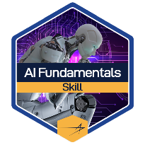](https://www.credly.com/badges/e144a08a-345f-4d2b-baf8-1c9d7fa99be6/public_url)[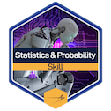](https://www.credly.com/badges/ea206568-8527-4fcc-b3d3-d361136657b7/public_url)**[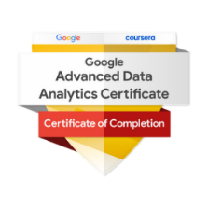](https://www.credly.com/badges/837f95d6-e710-4c2f-a9e9-bd9ab3888777/public_url)Certifications**

* **AI Fundamentals Skills** [**Badge**](https://www.credly.com/badges/e144a08a-345f-4d2b-baf8-1c9d7fa99be6/public_url) **and Practitioner** [**Badge**](https://www.credly.com/badges/11760d13-cb60-4ca7-9bdf-5838e6f6cf69/public_url)
* **Google Advanced Data Analytics** [**Certificate**](https://www.credly.com/badges/837f95d6-e710-4c2f-a9e9-bd9ab3888777/public_url)
* **Statistics and Probability for Python - LM Skills** [**Badge**](https://www.credly.com/badges/ea206568-8527-4fcc-b3d3-d361136657b7/public_url)

**Software**

Business Objects, SAP, ECM, MAP, CAPP, ETS, MATLAB, Solidworks, Minitab, Process Simulator, Pro/Engineer, IntelliCad, DraftSight, Qlikview, Tableau ([Portfolio](https://public.tableau.com/app/profile/donald.tucker)), SQL, Python, HTML, CSS